-->

[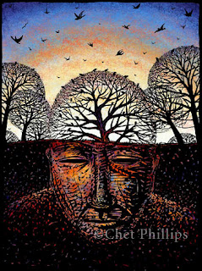](http://2.bp.blogspot.com/_c_oCoDXYEuc/S_-P9C7s_uI/AAAAAAAAAOQ/Sswd5Y7oItA/s1600/thought.jpg)

How many lives do I live? How many lifetimes exist within me?

No matter how much I may deny it, no matter how much I may try, I am not just me. My way was no longer genuine from the very moment I started to understand. My way of thinking, my principles, ethics, almost everything that I might claim to be mine, is influenced from everybody I know. Its something not invented, but is imbibed from the surroundings. Not even a single person, to whom I might have talked to, no matter how small that talk would have been, has not failed to implant some thought process of his on my mind.

Even if I wanted to learn every thing on my own, I cannot just shut down my senses to this world? I wonder, if the world around me, and the people who adorn the pages in history and all other literature, if all of them would somehow come alive again, and look inside me, how many of them would find a part of them, their ideologies thriving inside me? No matter how small it would be, but I am sure it would certainly be there. But then, they also learned it from somewhere, but where?

If I, myself am to look inside me, how many thoughts that I own would I find are actually my own? Am I really original, or just a myriad of different hues? Am I a master piece or just a clown stuffed with foreign ideas and draped in the tapestries from different designers?

Even now when I am writing these views here, I am still wondering, are these original and indigenous? Have I come to realize this on my own or even these questions have been asked before by someone, and I have just breathed them in like air?

I have no answer, and am pretty convinced with this fact that I would never be sure.

What about you?